‘Introduce, Align and Integrate’ – Innovative Induction into the NHS for International Medical Graduates

Dr Barbara Cassimon, Core Medical Trainee
Dr Katherine Smith, Consultant in Acute Medicine
Dr Rahul Sarkar, Consultant in ICM/Respiratory Medicine
Dr Ashike Choudhury, Consultant in Emergency Medicine
Dr Katina Damaskinidou, Consultant in Psychiatry
Dr Manisha Shah, Consultant in Anaesthetics and Simulation Lead
Gemma Wrighton, Simulation Department Manager

Special thanks to Gary Knowles and Elizabeth Rickard

Introduction

In today’s NHS (National Health Service), there is a heavy reliance on International Medical Graduates (IMG). Over a third of doctors working in the UK qualified in other countries. In spite of the UK’s international reputation as a good place to work and train as a medical professional,² there are a high number of vacancies for medical jobs in the UK.^{3,4} These are expected to rise after the UK leaves the EU (European Union) in 2019, as 10% of the medical workforce is originally from the EU/EEA (European Economic Area).

Working and living in the UK as an International Medical Graduate comes with specific challenges⁵, like difficulties with communication, culture, practical issues, team working and
hierarchical structures⁶ leading to an impact on morale and assimilation of these staff.

In this paper, we would like to describe our experience with IMG as part of the Medical Training Initiative (M.T.I.) for internal medicine registrar roles.⁷ At Medway NHS Foundation Trust, we had gaps on the medical registrar rota. There were six substantive registrars on an eighteen registrar rota leading to heavy reliance on temporary staff with consequent patient safety concerns and a high economic burden to the Trust.
The Trust provides medical care to a large catchment area, with pockets of severe deprivation, resulting in a high workload for medical staff¹⁸. In the years 2013-2017, the Trust was placed in special measures and rated ‘inadequate’ by the Care Quality Commission (CQC). This was (in part) due to patient safety issues, of which contributory factors were a lack of resources and rota gaps. The number of medical registrars on call had to be reduced from 4 per 24hrs to 3 per 24hrs. This had a significant impact on trainees’ wellbeing, with concerns being raised regarding increasing workload and pressure in the GMC Trainee Survey¹⁶.

Our project – ‘Introduce, Align and Integrate’

Concept
The Medical Training Initiative (MTI) programme was one of the solutions the Trust tried⁷. It is a national scheme which allows a small number of doctors to enter the UK from overseas for a maximum of 24 months, to benefit from UK training and development while working in NHS services before returning to their home countries⁷.

There was initial success in recruitment (10 registrar level IMGs). However, it became apparent after a few months that this group of doctors had not progressed to the role for which they were employed- i.e. the medical registrar on call rota. An analysis identified that the generic Trust and departmental inductions designed for local healthcare professionals was not fit for purpose for this group of doctors. As is common in many trusts, the programme assumes background knowledge of NHS Culture, Values and Ethics. There was also a limited understanding of the background knowledge and skills of these doctors leading to reluctance to incorporate them on the medical registrar rota.
Also, as they were not in training posts, they were rostered in to fill up gaps in different wards, rather than being allocated to their specialty in which they had been trained in their home country.

The aim of this simulation based training was initially to introduce these doctors to how the NHS works, align them with the values it represents, and integrate them into the existing system.
Two essential components of this project were a high fidelity simulation - based training and a workshop focusing on resilience and reflection. This would allow them to practice common scenarios encountered in acute medicine and skills in a safe environment, and provide them with resources and techniques to help them deal with anxiety and stress.

Structure of the course
The training programme was structured over four days, tackling some of the different issues that international medical graduates (IMGs) frequently encounter when transferring to the UK. These issues were identified by informal feedback from the Trust’s Local Academic Board and the IMGs. The international medical graduates reported limited benefit from the generic induction programme.¹

The main educational principles behind the course were spiral learning/experiential learning through simulation-based education and debriefing^{8,9} with pre- and post-course assessment of the participants’ abilities by competence and confidence questionnaires. During a second day of simulation-based training, the IMGs experienced more complex clinical scenarios representative of challenges facing their role as practicing on call medical registrars.
Reflective workshops on the first and final days of the course focused on aspects required for today’s NHS, other than clinical skills. The aim was to empower the IMGs, by providing them with a better understanding of the NHS as a system, and by introducing reflective practice as a tool for spiral learning in group discussions. Special attention was paid to medicolegal aspects of working as a medical registrar (Mental Health Act¹¹ and Mental Capacity Act¹⁷, including sectioning of patients and formally assessing capacity), dealing with challenging behavior, its impact on the doctor-patient relationship and recent changes within the NHS after the Francis report¹².
GMC guidance on reflective practice was clarified as well¹⁵, and reflective team discussions¹³ were used as a spiral learning technique and helped the trainees voice their experiences.

During these discussions, confidentiality was emphasized, to reassure the MTIs that it was a safe space for sharing and their experiences and reflections would facilitate further learning. By building on each other’s thoughts and expressing their doubts and fears in a group, it helped them realize that they were not alone in having these experiences.

The reflective workshop was followed by a hands-on workshop for practical skills, and day three was dedicated to high-fidelity simulation training. During the simulation training, the scenarios became increasingly complex to maximize their ability to learn, reflecting the principles of spiral learning.

Four weeks later, they attended a hybrid simulation – based education day which reflected a day on the ward with inbuilt skills followed by a second resilience workshop, focused on systemic challenges for doctors in a general hospital. At the end of the course, the applicants filled out a second competence/confidence survey, to assess for any changes. (see tables below)

Evaluation of the Course
The four stages of Kirkpatrick¹⁹ Evaluation are well described but have been updated and modified over time.

These have been used to evaluate the SPORTT course. Methods of evaluation included informal verbal feedback during the course, anonymized pre and post-course competence and confidence questionnaires, GMC trainee survey, information from the Resuscitation Officers and Medical consultants supervising the on-call registrars.

Level 1
Customer Satisfaction
All trainees reported satisfaction with venue and organization of the course at informal feedback and post course questionnaires.

Engagement
The IMGs contributed with punctual attendance and investment of their time away from clinical commitments. In addition, their input shaped the content of the course. As described above, an important part of the course was the session with the psychotherapy-trained facilitator and the IMGs engaged in this process. They also had to engage with the simulation debriefing sessions, which was evident by the contributions from all participants.

Relevance
The course was designed with real-world outputs in mind- i.e. the IMGs being able to work on the medical registrar on-call rota. It was designed by clinicians with experience in simulation to address the issues facing registrars. In feedback, the IMGs confirmed that the course had been relevant to their educational needs. They all agreed that this course should be part of induction for future MTI doctors.

Level 2: Learning
The degree to which participants acquire the intended knowledge, skills, attitude, confidence and commitment based on their participation in the training:

Knowledge/Skill
The candidates were assessed formatively on their clinical and non-technical knowledge and skills during the simulation sessions. Common clinical dilemmas were presented and the debrief included an opportunity for candidates to identify learning points.

At the end of the course, seven out of ten MTIs were deemed competent to go on medical registrar rota and other three joined them after few months.

Attitude/Confidence
Before the course, many participants reported lack of confidence with several practical procedures, as well as with other aspects of clinical care, such as communication with patients and relatives.

Many of the participants reported feeling more confident in actively participating in a multidisciplinary team after completing the course, and they also reported increased tendency to openly discuss concerns and escalate these.

Pre and post course competence and confidence self-reported questionnaires:

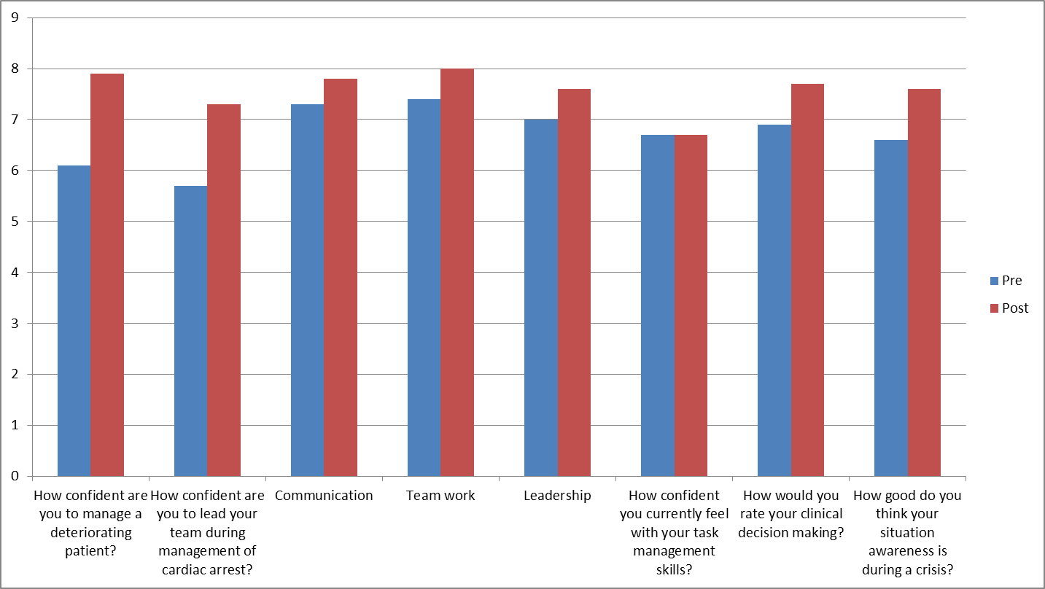

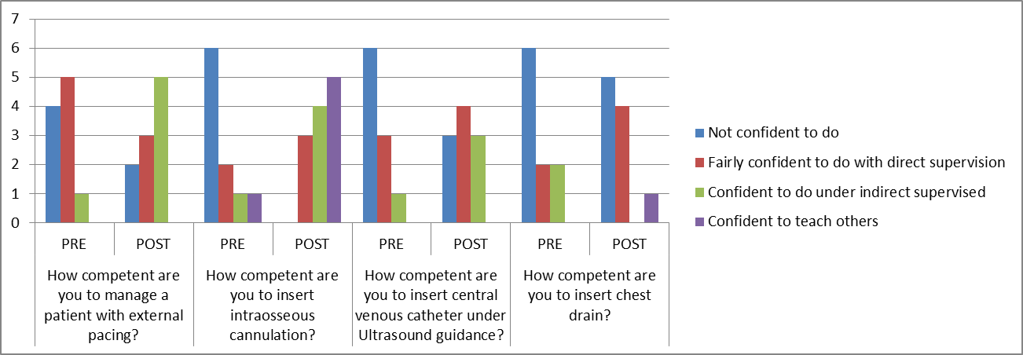

Commitment
All the MTI trainees felt that this course supported them to adjust to a new system and new concepts like ‘SBAR’. They appreciated the reinforcement of standards of strict asepsis during skills’’ workshop. MTIs discussed patient autonomy and shared decision-making during debriefing following simulation scenarios. Some MTIs were surprised at low numbers of nurses and doctors per ward in UK but appreciated introduction of specialist roles such as specialist nurses for respiratory or cardiovascular conditions, A.R.T. (acute response team) nurses, the site managers, and the multidisciplinary cardiac arrest team, to name a few during simulation.

Level 3: Behaviour
The degree to which participants apply what they learned during training when they are back on the job:
Feedback from candidates at follow-up meeting included:
‘I use SBAR for my written communications as well’.
‘During one cardiac arrest, I was urged by the family members to start chest compressions in spite of [the] patient deciding for DNAR. I followed [the] patient’s wishes and respected [the] patient’s autonomy. In my country, I would have started resuscitation.’

During the reflective workshop the facilitator, who has a medical psychotherapy background, would maintain a so-called "not knowing" stance¹⁴, which helped create a non-judgmental atmosphere of acceptance. This was important in order to facilitate the free expression of ideas and comparisons between the trainees’ cultural background in relation to work in their native countries and in the UK without the fear of being labelled as “wrong” by the dominant culture. The aim was also to increase awareness and encourage the sharing of ideas and experiences relevant to power dynamics with reference to race, gender and hierarchy within the hospital work environment. Constructive criticism in relation to their perceptions of the NHS structures in the microenvironment of the hospital was also encouraged and valued during the discussions.

Required Drivers
The chart below summarises the areas of changes in behaviour in the real world:

Confident, competent, supported registrars

MTIs understand their role , are valued and supported

Skills and coping strategies to enable integration into the medical registrar rota

PACES success

MTIs have become simulation faculty members

MTIs undertaking research projects

MTIs supporting hospital QIPs

Support other trainees’ education

Trainees expressing that workload and pressure is more manageable

Level 4: Results
Seven out of ten candidates were promoted to the on-call rota after the course and the remaining three did after a period of consolidation of a couple of months.

Leading Indicators
Medical consultants reported confidence in the performance of the IMGs on the post-take ward rounds. Two members of the SPORTT Faculty work on the medical consultant rota and were able to make direct observations themselves as well as collect feedback from consultant colleagues.
Another member of the Faculty is an Emergency Department consultant and was able to note the improved communications skills and professionalism when these IMGs were referred patients from the Emergency Department.

Patient Safety
Potentially avoidable cardiac arrest calls fell by 53% from 2017 to 2018 according to the Trust Resuscitation Officers. This was attributed to more judicious use of DNR (Do not resuscitate) and TEP (Treatment Escalation Protocols) and earlier escalation of deteriorating patients.

CQC report 2.10.18
‘Improvement in the management of deteriorating patients and sepsis.’
‘Examples of outstanding care in urgent and medical care.’

Financial Savings
The cost of the course was £1942.50 for 10 candidates.
A substantive medical registrar costs £ 5,702 per month as compared to £15,655 for a locum registrar, achieving about £9,945 savings per month per registrar slot. With seven of our MTIs now fulfilling this role we have been able to substantially reduce agency costs for locum registrars.
The chart below shows our monthly financial savings following this course.

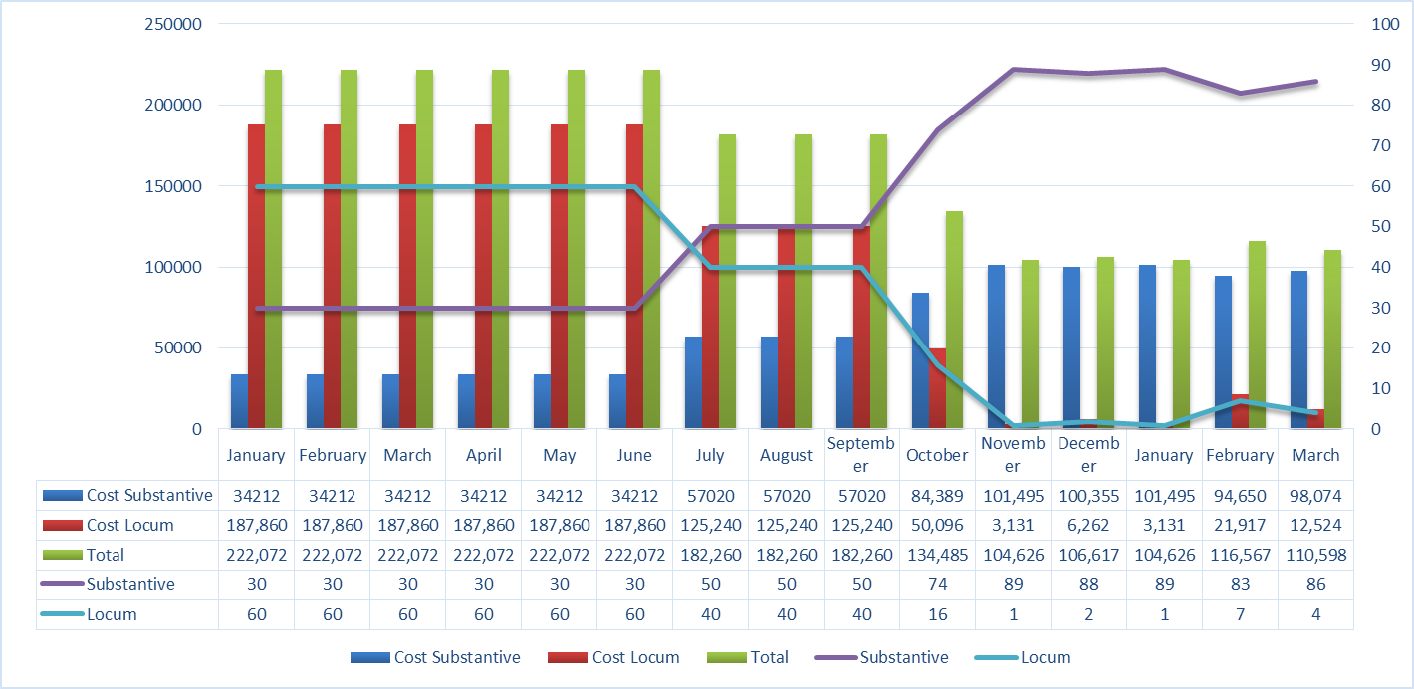

Conclusion
As per discussion above, integration of IMG doctors in the NHS comes with unique challenges which need a tailored approach.
We used our existing knowledge and skills as a simulation faculty and experience from other training courses to develop this induction programme for MTI trainees, making it widely available and sustainable.
The cost savings by cutting down the agency staff makes it financially viable and improves patient safety by ensuring continuity of care.
This training programme for IMG doctors at the commencement of their placements speeds up integration and enhances the experience from the MTI placements in the NHS. As a result, it is expected to have a positive impact on the health care systems of the doctors’ native countries when they return and share the lessons.

Future:
We are planning to have more patient involvement for future courses for scenario writing and as patient actors.
Following feedback from the MTI trainees, we are also proposing a buddy system for future MTIs and planning to introduce this course at early stage as part of the induction.
This course will be offered to our Clinical Trust Fellows (CTF) and Internal medicine trainees.
The MTI leadership group at Royal College of Anaesthetists RCOA has discussed the possibility of delivering a shortened version of such training to their anaesthetic MTIs.
One of our MTI trainees is planning to set up such training in Nigeria.

References

1 Bhat, M., Ajaz, A. and Zaman, N. (2014). Difficulties for international medical graduates working in the NHS. BMJ, p.g3120.

2 Times Higher Education (THE). (2019). Best universities for medicine. [online] Available at: https://www.timeshighereducation.com/student/best-universities/best-universities-medicine [Accessed 26 Jun. 2019].

3 Royal College of Physicians of Edinburgh (RCPE). (2019). Physicians' Census | Royal College of Physicians of Edinburgh. [online] Available at: https://www.rcpe.ac.uk/college/physicians-census [Accessed 26 Jun. 2019].

4 NHS Digital. (2019). NHS Vacancy Statistics England, February 2015 - March 2019, Provisional Experimental Statistics - NHS Digital. [online] Available at: https://digital.nhs.uk/data-and-information/publications/statistical/nhs-vacancies-survey/february-2015---march-2019-provisional-experimental-statistics [Accessed 30 May 2019].

5 Warwick University. (2019). Non UK qualified doctors and good medical practice : the experience of working within a different professional framework. Report for the General Medical Council. - WRAP: Warwick Research Archive Portal. [online] Available at: http://wrap.warwick.ac.uk/72969/

6 Slowther, A., Lewando Hundt, G., Purkis, J. and Taylor, R. (2012). Experiences of non-UK-qualified doctors working within the UK regulatory framework: a qualitative study. Journal of the Royal Society of Medicine, 105(4), pp.157-165.

7 Academy of Medical Royal Colleges. (2019). Medical Training Initiative - Academy of Medical Royal Colleges. [online] Available at: http://www.aomrc.org.uk/medical-training-initiative/

8 Chmil, J., Turk, M., Adamson, K. and Larew, C. (2015). Effects of an Experiential Learning Simulation Design on Clinical Nursing Judgment Development. Nurse Educator, 40(5), pp.228-232.

9 Nursingeducation.lww.com. (2019). How Using a Spiral Curriculum in Nursing Can Help Students Grasp Even the Most Difficult Nursing Concepts. [online] Available at: http://nursingeducation.lww.com/blog.entry.html/2017/03/11/how_using_a_spiralc-s0DX.html [Accessed 25 May 2019].

10 General Medical Council (GMC). (2019). National Training Surveys 2018: Initial findings report. [online] Available at: https://www.gmc-uk.org/-/media/documents/dc11391-nts-2018-initial-findings-report_pdf-75268532.pdf [Accessed 25 May 2019].

11 Department of Health (1983). Mental Health Act 1983. [online] Available at: https://web.archive.org/web/20151120051601/http://www.legislation.gov.uk/ukpga/1983/20/contents [Accessed 20 May 2019].

12 Francis, R. (2013) Report of the Mid Staffordshire NHS Foundation Trust Public Inquiry. [online] Available at: http://www.midstaffsinquiry.com/pressrelease.html [Accessed 20 May 2019].

13 Andersen, T. (1987). The Reflecting Team: Dialogue and Meta-Dialogue in Clinical Work. Family Process, 26(4), pp.415-428.

14 Anderson, H. (1997). Conversation, language, and possibilities. New York, N.Y.: BasicBooks.

15 General Medical Council (GMC). (2018). New guidance to help you with reflection. [online] Available at: https://www.gmc-uk.org/news/news-archive/new-guidance-to-help-you-with-reflection [Accessed 20 May 2019].

16 General Medical Council (GMC). (2016). National Training Survey 2016 [online] Available at: https://www.gmc-uk.org/-/media/documents/National_training_survey_2016_England.pdf_66922358.pdf [Accessed 20 Jun. 2019].

17 Department of Health. (2005). Mental Capacity Act 2005. [online] Available at: https://www.legislation.gov.uk/ukpga/2005/9/contents [Accessed 20 May 2019].

18 Medway Council. (2016). Index of deprivation 2015. [online] Available at: https://www.medway.gov.uk/download/downloads/id/241/deprivation_index.

19 Philosophy, O. and Model, T. (n.d.). The Kirkpatrick Model. [online] Kirkpatrickpartners.com. Available at: https://www.kirkpatrickpartners.com/Our-Philosophy/The-Kirkpatrick-Model [Accessed 25 Aug. 2019].

